METAL AND NON METAL CLASS-10TH PHYSICS PYQ (STUDY MATERIAL)
Previous Year Questions 2024
Q1: A metal and a non-metal that exists in liquid state at room temperature are respectively: (2024)
(a) Bromine and Mercury
(b) Mercury and Iodine
(c) Mercury and Bromine
(d) Iodine and Mercury
Ans: (c)
- Mercury is a metal that is liquid at room temperature.
- Bromine is a non-metal that is also liquid at room temperature.
- Thus, the correct answer is (c) Mercury and Bromine.
Q2: Oxides of aluminum and zinc are: (2024)
(a) acidic
(b) basic
(c) amphoteric
(d) neutral
Ans: (c)
Oxides of aluminum and zinc are classified as amphoteric.
This means they can react with both acids and bases, displaying the following characteristics:
- They can act like acids in some reactions.
- They can behave like bases in other reactions.
- This versatility makes them important in various chemical processes.
Q3: The metals which are found in both free state as well as combined state are: (2024)
(a) Gold and platinum
(b) Platinum and silver
(c) Copper and silver
(d) Gold and silver
Ans: (c)
The correct answer is (c) Copper and silver. These metals can be found in their pure, uncombined form (free state) in nature, as well as in compounds with other elements (combined state). This means they can exist both as standalone metals and as part of various minerals.
Q4: A metal ‘X’ is used in the thermit process. When ‘X’ is heated with oxygen, it gives an oxide ‘Y’, which is amphoteric in nature. ‘X’ and ‘Y’ respectively are: (2024)
(a) Mn, MnO₂
(b) Al, Al₂O₃
(c) Fe, Fe₂O₃
(d) Mg, MgO
Ans: (b)
Metal ‘X’ is aluminium, used in the thermit process. When aluminium is heated with oxygen, it produces aluminium oxide (Y), which is amphoteric. This means it can react with both acids and bases.
- Metal X: Aluminium (Al)
- Oxide Y: Aluminium oxide (Al₂O₃)
- Nature: Amphoteric
Q5: Source-based/case-based questions with 2 to 3 short subparts. (2024)
The metals produced by various reduction processes are not very pure. They contain impurities, which must be removed to obtain pure metals. The most widely used method for refining impure metals is electrolytic refining.
(i) What is the cathode and anode made of in the refining of copper by this process?
(ii) Name the solution used in the above process and write its formula.
(iii) (A) How does copper get refined when electric current is passed in the electrolytic cell?
OR
(iii) (B) You have two beakers ‘A’ and ‘B’ containing copper sulphate solution. What would you observe after about 2 hours if you dip a strip of zinc in beaker ‘A’ and a strip of silver in beaker ‘B’? Give reasons for your observations in each case.
Ans: (i) The cathode is made of pure copper and the anode is made of impure copper.
(ii)) The solution used in this process is acidified copper sulphate, with the formula CuSO₄.
(iii) (A) When electric current is passed through the electrolytic cell:
- Pure copper from the anode dissolves into the electrolyte.
- An equivalent amount of pure copper is deposited on the cathode.
- Soluble impurities enter the solution.
- Insoluble impurities settle at the bottom of the anode, forming anode mud.
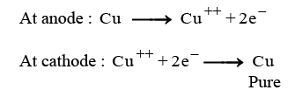
OR
(iii) (B) Observations after 2 hours:
- Beaker A: The blue colour of the solution fades or becomes colourless.
- Reason: Zinc is more reactive than copper, displacing it from the solution.
- Beaker B: No change in colour is observed.
- Reason: Silver is less reactive than copper, so no reaction occurs.
Q6: Assertion - Reason based questions: These questions consist of two statements — Assertion (A) and Reason (R). Answer these questions selecting the appropriate option given below: (2024)
Assertion (A) : Different metals have different reactivities with water and dilute acids.
Reason (R): Extraction of a metal from its ore depends on its position in the reactivity series.
(a) Both (A) and (R) are true and (R) is the correct explanation of (A).
(b) Both (A) and (R) are true, but (R) is not the correct explanation of (A).
(c) (A) is true, but (R) is false.
(d) (A) is false, but (R) is true.
Ans: (b)
Assertion (A) is correct because different metals react differently with water and acids. However, while Reason (R) is also true, it explains how we extract metals rather than directly explaining why their reactivities vary.
Q7: State reasons for the following: (2024)
(a) Zinc oxide is an amphoteric oxide.
(b) Sodium metal is stored in bottle filled with kerosene oil.
(c) In the reactions of nitric acid with metals, generally hydrogen gas is not evolved.
Ans: (a) Amphoteric oxide (zinc oxide) reacts with acids as well as bases to produce salt and water.
- Reaction with acids: Zinc oxide reacts with acids to form a salt and water. For example:
ZnO+2HCl→ZnCl₂+H₂O
- Reaction with bases: Zinc oxide reacts with strong bases to form a salt (zincate). For example:
ZnO+2NaOH+H₂O→Na₂[Zn(OH)₄]
(b) If kept in open, sodium metal reacts vigorously with air and catches fire / kerosene oil does not allow sodium to come in contact with air and catch fire.
(c) Nitric acid is a strong oxidising agent. It oxidises the hydrogen produced in the reaction to water. This is due to the strong oxidizing nature of nitric acid, which reduces itself to nitrogen oxides (like NO, NO₂) while oxidizing the hydrogen.
Q8: (a) State giving reason the reduction process to obtain the following metals from their compounds: (2024)
(i) Mercury,
(ii) Copper and
(iii) Sodium
OR
(b) State giving reason for the change in appearance observed when each of the following metal is exposed to atmospheric air for some time:
(i) Silver,
(ii) Copper and
(iii) Iron
Ans: (a) (i) Reduction Process- Roasting
Reason: Mercury has low reactivity.
(ii) Reduction Process- Roasting
Reason: Copper has low reactivity.
(iii) Reduction Process- Electrolytic Reduction.
Reason: Sodium has high reactivity.
OR
(b) (i) Change in appearance - White to black colour.
Reason: Silver sulphide is formed.
(ii) Change in appearance – Reddish brown to green colour.
Reason: Basic Copper Carbonate is formed.
(iii) Change in appearance- Grey to brown colour.
Reason: Rust (iron oxide) is formed.
Q9: Name the ore of mercury and state the form in which it is found in nature. Write the chemical equations along with the condition required for the reactions involved in the extraction of mercury from its ore. (2024)
Ans: Ore of mercury: Cinnabar
Form in nature: Sulphide ore
The extraction of mercury from cinnabar involves the following chemical reactions:
- When heated in air, cinnabar (HgS) converts to mercuric oxide (HgO):
- 2HgS(s) 3O₂(g) → 2HgO(s) 2SO₂(g)
- Further heating of mercuric oxide produces mercury:
- 2HgO(s) → 2Hg(l) O₂(g)
Q10: Some metals react with acids to produce salt and hydrogen gas. Illustrate it with an example. How will you test the presence of this gas? (2024)
Ans: Zn + H₂SO₄ → ZnSO₄ + H₂ (g)
To test for the presence of hydrogen gas:
- Bring a burning matchstick near the gas.
- If hydrogen is present, it will burn with a pop sound.
Q11: Assertion - Reason based questions: These questions consist of two statements — Assertion (A) and Reason (R). Answer these questions selecting the appropriate option given below: (CBSE 2024)
Assertion ( A): A piece of zinc metal gets reddish-brown coating when kept in copper sulphate solution for some time.
Reason (R): Copper is more reactive metal than zinc.
(a) Both (A) and (R) are true and (R) is the correct explanation of (A).
(b) Both (A) and (R) are true, but (R) is not the correct explanation of (A).
(c) (A) is true, but (R) is false.
(d) (A) is false, but (R) is true.
Ans: (c)
Assertion (A): A piece of zinc metal gets a reddish-brown coating when kept in copper sulfate solution for some time. This is true. When zinc is placed in a copper sulfate solution, a displacement reaction occurs where zinc displaces copper from copper sulfate. The copper then deposits on the zinc surface as a reddish-brown coating.
Reason (R): Copper is more reactive than zinc. This is false. In the reactivity series, zinc is more reactive than copper, which is why zinc can displace copper from copper sulfate.
Since Assertion (A) is true but Reason (R) is false, the correct answer is (c) (A) is true, but (R) is false
Q12: Consider the following compounds: (CBSE 2024)
FeSO₄; CuSO₄; CaSO₄; Na₂CO₃
The compound having maximum number of water of crystallisation in its crystalline form in one molecule is ______.
(a) FeSO₄
(b) CuSO₄
(c) CaSO₄
(d) Na₂CO₃
Ans: (d) Na₂CO₃
Na₂CO₃ ⋅ 10H₂O (hydrated sodium carbonate) has the largest concentration of water molecules in its crystalline structure, with 10 molecules per formula unit.

Previous Year Questions 2023
Q1: The following questions are source based/case based questions. Read the case carefully and answer the questions that follow. The melting points and boiling points of some ionic compounds are given below: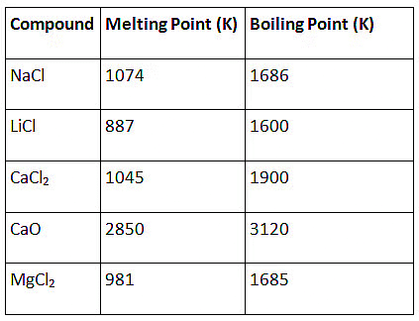
These compounds are termed ionic because they are formed by the transfer of electrons from a metal to a non-metal. The electron transfer in such compounds is controlled by the electronic configuration of the elements involved. Every element tends to attain a completely filled valence shell of its nearest noble gas or a stable octet.
(i) Show the electron transfer in the formation of magnesium chloride.
(ii) List two properties of ionic compounds other than their high melting and boiling points.
(iii) (A) While forming an ionic compound say sodium chloride how does sodium atom attain its stable configuration?
OR
(B) Give reasons:
(i) Why do ionic compounds in the solid state not conduct electricity?
(ii) What happens at the cathode when electricity is passed through an aqueous solution of sodium chloride? (2023)
Ans: (i) Transfer of electrons during the creation of magnesium chloride:
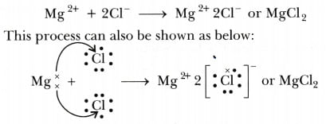(ii) The two properties of ions Compounds are:
(a) Solubility: Electrovalent compounds are generally soluble in water and insoluble in solvents such as kerosene, petrol, etc.
(b) Conduction of Electricity:
- The conduction of electricity through a solution involves the movement of charged particles.
- A solution of an ionic compound in water contains ions, which move to the opposite electrodes when electricity is passed through the solution.
- Ionic compounds in the solid state do not conduct electricity because movement of ions in the solid is not possible due to their rigid structure.
- But ionic compounds conduct electricity in the molten state.
- This is possible in the molten state since the electrostatic forces of attraction between the oppositely charged ions are overcome due to the heat.
- Thus, the ions move freely and conduct electricity.
(iii) (A)
- Sodium atom has one electron in its outermost shell.
- If it loses the electron from its M shell then its L shell now becomes the outermost shell and that has a stable octet.
- The nucleus of this atom still has 11 protons but the number of electrons has become 10, so there is a net positive charge giving us a sodium cation Na⁺.
- On the other hand chlorine has seven electrons in its outermost shell and it requires one more electron to complete its octet.
- If sodium and chlorine were to react, the electron lost by sodium could be taken up by chlorine.
- After gaining an electron, the chlorine atom gets a unit negative charge, because its nucleus has 17 protons and there are 18 electrons in its K, L and M shells.
- This gives us a chloride anion Cl–.
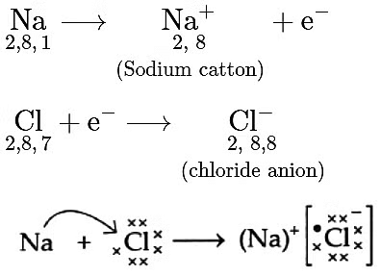
(B) (i)
- The conduction of electricity through a solution involves the movement of charged particles.
- A solution of an ionic compound in water contains ions, which move to the opposite electrodes when electricity is passed through the solution.
- Ionic compounds in the solid state do not conduct electricity because the movement of ions in the solid is not possible due to their rigid structure.
- But ionic compounds conduct electricity in the molten state.
- This is possible in the molten state since the electrostatic forces of attraction between the oppositely charged ions are overcome due to the heat.
- Thus, the ions move freely and conduct electricity.
(ii)When electricity is passed through a solution of sodium chloride in water, hydrogen gas is released twice as much as oxygen gas is released at the anode.
Q2: The following questions are source-based/case-based questions. Read the case carefully and answer the questions that follow. Metals are required for a variety of purposes. For this, we need their extraction from their ores. Ores mined from the earth are usually contaminated with many impurities which must be removed before the extraction of metals. The extraction of pure metal involves the following steps:
(1) Concentration of ore
(2) Extraction of metal from the concentrated ore
(3) Refining of metal
(a) Name an ore of mercury and state the form in which mercury is present in it.
(b) What happens to zinc carbonate when it is heated strongly in a limited supply of air?
(c) The reaction of a metal A with Fe₂O₃ is highly exothermic and is used to join railway tracks.
(I) Identify the metal A and name the reaction taking place.
(II) Write the chemical equation or the reaction of metal A with Fe₂O₃. (2023)
Ans: (a) An ore of mercury is cinnabar, and mercury is present in it in the form of mercury sulfide (HgS).
(b) When zinc carbonate (ZnCO₃) is heated strongly in a limited supply of air, it undergoes thermal decomposition to produce zinc oxide (ZnO), carbon dioxide (CO₂), and water (H₂O):
ZnCO₃(s) → ZnO(s) + CO₂(g)
(c) (I) The metal A is aluminium (Al), and the reaction is called the thermite reaction.
(II) The chemical equation for the reaction of iron (A) with iron(III) oxide (Fe₂O₃) is:
2Al(s) + Fe₂O₃(s) → 2Fe(s) + Al₂O₃(s)
This reaction is highly exothermic and is used in various industrial applications, including joining railway tracks due to its high heat generation and the ability to melt and fuse metals.
Q3: A metal ‘X’ is used in thermite process. When X is burnt in air it gives an amphoteric oxide 'Y'. 'X' and 'Y' are respectively:
(a) Fe and Fe₂O₃
(b) Al and Al₂O₃
(c) Fe and Fe₃O₄
(d) Al and Al₃O₄ (CBSE 2023)
Ans: (b)
In the thermite process, aluminum (Al) is used because of its high reactivity and ability to reduce metal oxides, such as iron oxide, to produce molten iron.
When aluminum is burnt in air, it forms aluminum oxide (Al₂O₃), which is an amphoteric oxide (meaning it can react with both acids and bases).
Therefore, X is aluminum (Al) and Y is aluminum oxide (Al₂O₃), making the correct answer (b) Al and Al₂O₃.
Q4: Almost all metals combine with oxygen to form metal oxides. Metal oxides are generally basic in nature. But some metal oxides show both basic as well as acidic behaviour. Different metals show different reactivities towards oxygen. Some react vigorously while some do not react at all.
(A) What happens when copper is heated in air? (Give the equation of the reaction involved).
(B) Why are some metal oxides categorised as amphoteric? Give one example.
(C) Complete the following equations:
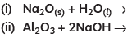
OR
(C) On burning sulphur in oxygen a colourless gas is produced.
(i) Write chemical equation for the reaction.
(ii) Name the gas formed.
(iii) State the nature of the gas.
(iv) What will be the action of this on a dry litmus paper? (CBSE 2023)
Ans: (A) Copper is a reactive element. When it is heated in the air, it forms black copper oxide (CuO).
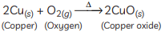(B) Metal oxides are categorised as amphoteric oxides that react with both acids as well as bases to create salts and water. Amphoteric oxides, among many others, include lead oxide and zinc oxide. These oxides are oxygen compounds that show both acidic and basic characteristics. These undergo a neutralisation reaction to form water and salt.
Example:
(C) 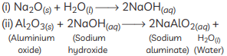
OR
(C) (i)
(ii) The gas formed is sulphur dioxide which is colourless and poisonous.
(iii) The nature of the gas is acidic.
(iv) SO₂ gas has no effect on dry litmus paper because it shows acidic behavior only in the presence of water
Previous Year Questions 2022
Q1: A clear solution of slaked lime is made by dissolving Ca(OH)₂ in an excess of water. This solution is left exposed to air. The solution slowly goes milky as a faint white precipitate form. Explain why a faint white precipitate forms, and support your response with the help of a chemical equation.
OR
Keerti added dilute Hydrochloric acid to four metals and recorded her observations as shown in the table given below:
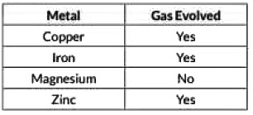Select the correct observation(s) and give chemical equation(s) of the reaction involved. (2022)
Ans: When a clear solution of slaked lime (Ca(OH)₂) is exposed to air, carbon dioxide (CO₂) from the atmosphere dissolves into the solution and reacts with the dissolved calcium hydroxide. This reaction produces calcium carbonate (CaCO₃), which is insoluble and appears as a faint white precipitate (“milky” appearance). The chemical equation is:
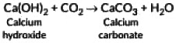Thus, the “milkiness” arises from the formation of solid calcium carbonate.
OR
- Copper (below H)
  - Does not react with dilute HCl to give hydrogen gas.
  - No visible reaction under normal conditions.
- Iron (above H)
  - Does react to produce hydrogen gas.
  - Reaction: Fe(s) + 2HCl(aq) → FeCl₂(aq) + H₂(g)
- Magnesium (above H)
  - Does react quite vigorously, giving hydrogen gas.
  - Reaction: Mg(s) + 2HCl(aq) → MgCl₂(aq) + H₂(g)
- Zinc (above H)
  - Does react, evolving hydrogen gas.
  - Reaction: Zn(s) + 2HCl(aq) → ZnCl₂(aq) + H₂(g)
Therefore, corrected table becomes :
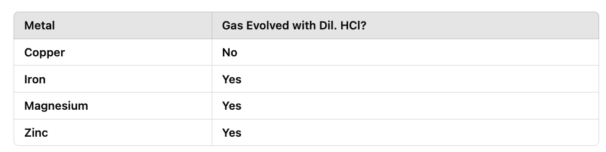
So, the correct observations are for iron and zinc only.
Previous Year Questions 2021
Q1: Why is potassium kept immersed in kerosene? (2021 C)
Ans:
- Potassium is kept immersed in kerosene because it reacts vigorously with air and water.
- The reaction with air forms a layer of potassium oxide on the surface, while the reaction with water produces potassium hydroxide.
- Both of these reactions release hydrogen gas, which is highly flammable.
- By keeping potassium immersed in kerosene, it is protected from air and water, preventing any unwanted reactions.
Q2: Give a reason why:
(a) gold and silver are used for making jewellery.
(b) a few metals are used for making cooking utensils. (2021 C)
Ans: (a) Gold and silver are highly malleable metals so, they are used for making jewellery.
(b) Metals used to make cooking utensils are chosen not just for their good heat conduction but also for their relatively low reactivity. You generally don’t want a metal that reacts with food or with the conditions (high temperature, presence of water vapor, mild acids in food, etc.). Here’s how it ties to reactivity:
- Metals below hydrogen in the reactivity series (like copper, silver, gold) do not readily react with acids or water under normal cooking conditions.
- Metals that form stable oxide layers (like aluminum, which is higher in the series) are protected from further corrosion by that oxide coating.
- Alloys such as stainless steel (predominantly iron but mixed with chromium/nickel) also resist corrosion because chromium forms a very adherent oxide layer that protects the iron underneath.
Thus, metals like iron (in stainless steel), aluminum, and copper are commonly used for utensils because:
- They do not corrode easily or leach into food.
- They are good conductors of heat.
- They maintain a protective surface layer (oxide or alloy layer), preventing further reaction
Previous Year Questions 2020
Q1: Compare in tabular form the reactivities of the following metals with cold and hot water: (2020)
(a) Sodium
(b) Calcium
(c) Magnesium
Ans:
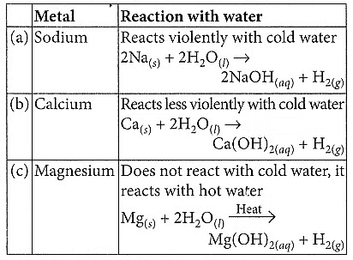
Q2: (a) Write the electron dot structure of Ca (At. No. 20) and O (At. No. 8).
(b) Show the formation of calcium oxide by the transfer of electrons.
(c) Name the ions present in this compound.
(d) List four important characteristics of this compound. (2020)
Ans:
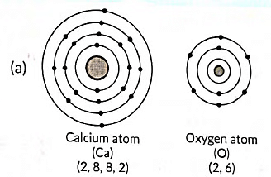
(b) The formation of calcium oxide (CaO) involves the transfer of electrons. Calcium (Ca) donates two electrons to oxygen (O) to form Ca²⁺ cation and O²⁻ anion. The ionic bond is formed between these ions to create calcium oxide.
(c) In calcium oxide (CaO), the ions present are Ca²⁺ (calcium cation) and O²⁻ (oxygen anion).
(d) Four important characteristics of calcium oxide (CaO) are:
- It is a white, crystalline solid.
- It has a high melting and boiling point.
- It is an ionic compound.
- It is commonly used as a desiccant and in cement production.
Q3: List three differentiating features between the processes of galvanisation and alloying. (2020)
Ans: Three differentiating features between the processes of galvanisation and alloying are as follows:
- Definition: Galvanisation is the process of applying a protective zinc coating to iron or steel to prevent corrosion, while alloying is the process of combining two or more metals or metals with a non-metal to create a new material with enhanced properties.
- Purpose: Galvanisation is primarily used to protect the base metal from corrosion by providing a sacrificial layer of zinc, whereas alloying is done to improve specific properties of the metal, such as strength, hardness, or resistance to corrosion.
- Procedure: In galvanisation, the metal is coated with zinc through processes like hot-dip galvanisation or electroplating. On the other hand, alloying involves melting and mixing different metals or adding non-metallic elements to create an alloy with the desired properties.
Q4: (a) Complete and balance the following chemical equations: (2020)
(i) AI₂O₃ + HCI →
(ii) K₂O + H₂O →
(iii) Fe + H₂O →
(b) An element 'X' displaces iron from the aqueous solution of iron sulphate. List your observations if the element 'X’ is treated with the aqueous solutions of copper sulphate, zinc sulphate and silver nitrate. Based on the observations arrange X, Zn, Cu and Ag in increasing order of their reactivities.
Ans: (a) Complete and balance the following chemical equations:
(i) AI₂O₃ + 6HCl → 2AlCl₃ + 3H₂O
(ii) K₂O + H₂O → 2KOH
(iii) Fe + 2H₂O → Fe(OH)₂ + H₂
(b) Observations:
- When element 'X' is treated with copper sulphate solution, no reaction occurs.
- When element 'X' is treated with zinc sulphate solution, 'X' displaces zinc from the solution, resulting in the formation of 'X' sulphate and zinc metal.
- When element 'X' is treated with silver nitrate solution, 'X' displaces silver from the solution, resulting in the formation of 'X' nitrate and silver metal.
Based on the observations, the increasing order of reactivities is:
Ag<Cu<Zn<X
Q5: (i) By the transfer of electrons, illustrate the formation of a bond in magnesium chloride and identify the ions present in this compound.
(ii) Ionic compounds are solids. Give reasons.
(iii) With the help of a labelled diagram show the experimental set-up of steam action on a metal. (2020)
Ans:
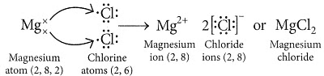
(ii) Ionic compounds are solids because the particles that make up ionic compounds are held together by strong electrostatic bonds.
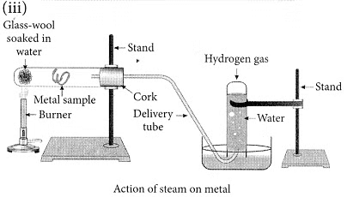
Q6: (a) (i) Write two properties of gold that make it the most suitable metal for ornaments.
(ii) Name two metals which are the best conductors of heat.
(iii) Name two metals that melt when you keep them on your palm.
(b) Explain the formation of the ionic compound CaO with an electron-dot structure. Atomic numbers of calcium and oxygen are 20 and 8 respectively. (2020)
Ans: (a) (i) The malleability and ductility properties of gold make it suitable for ornaments. Also, beacause of less reactive natureof gold, it's prefered for making jewellery.
(ii) Silver and gold.
(iii) Gallium and caesium have so low melting points that they melt even on keeping them in the palm.
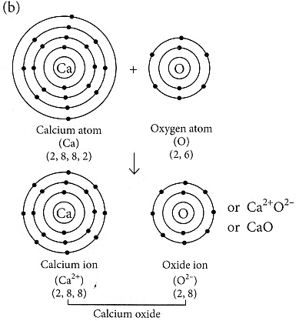
(b) Formation of the ionic compound CaO (calcium oxide) with an electron-dot structure:
Calcium oxide (CaO) is formed through the transfer of electrons between calcium (Ca) and oxygen (O) atoms. Calcium, with an atomic number of 20, loses two electrons to achieve a stable electron configuration similar to that of a noble gas (argon), while oxygen, with an atomic number of 8, gains two electrons to complete its valence shell.
The electron-dot structure of CaO can be represented as follows:
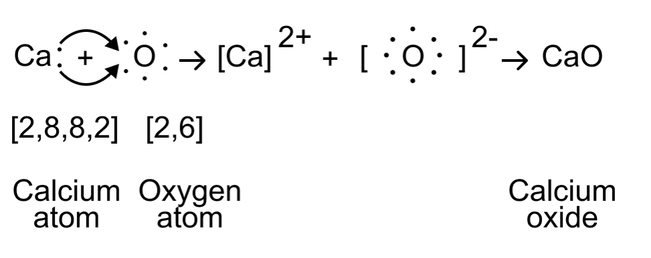
In this structure, the calcium atom loses its two valence electrons to oxygen, resulting in a Ca²⁺cation and an O²⁻ anion. The electrostatic attraction between these oppositely charged ions forms the ionic bond in calcium oxide (CaO).
Q7: Carbon cannot reduce the oxides of sodium, magnesium and aluminium to their respective metals. Why? Where are these metals placed in the reactivity series? How are these metals obtained from their ores? Take an example to explain the process of extraction along with chemical equations. (2020)
Ans: Sodium, magnesium and aluminium have a higher affinity towards oxygen than carbon because these are highly reactive metals. Hence, carbon cannot reduce the oxides of sodium, magnesium and aluminium to their respective metals. These metals are placed at the top of the reactivity series. Highly reactive metals like Na, Mg, Al, etc. are extracted by electrolytic reduction of their molten chlorides or oxides. Electrolytic reduction is brought about by passing electric current through the molten state. Metal gets deposited at the cathode.
NaCl ⇌ Na⁺ + Cl–
At cathode : Na⁺ + e– → Na⁺
At anode : 2Cl– → Cl₂ + 2e–
Q8: Write balanced chemical equations to explain what happens, when
(i) Mercuric oxide is heated.
(ii) A mixture of cuprous oxide and cuprous sulphide is heated.
(iii) Aluminium is reacted with manganese dioxide.
(iv) Ferric oxide is reduced with aluminium.
(v) Zinc carbonate undergoes calcination. (2020)
Ans: (i) On heating, mercuric oxide decomposes to give mercury and oxygen.
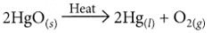
(ii) On heating a mixture of cuprous oxide and cuprous sulphide, copper and sulphur dioxide are produced.
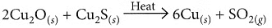
(iii) When aluminium is heated with manganese dioxide, manganese and aluminium oxide are formed.
(iv) Ferric oxide reacts with aluminium to produce aluminium oxide and iron.
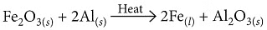
(v) On calcination, zinc carbonate produces zinc oxide and carbon dioxide.
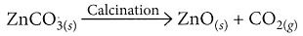
Q9: (a) Name the following: (CBSE 2020)
(i) Metal that can be cut by a knife
(ii) Lustrous non-metal
(iii) Metal that exists in liquid state at room temperature
(iv) Most malleable and ductile metal
(v) Metal that is the best conductor of electricity
(vi) Non-metal that can exist in different forms
(b) How are alloys better than metals? Give the composition of solder and amalgam.
Ans: (a) (i) Sodium
(ii) Iodine
(iii) Mercury
(iv) Gold
(v) Silver
(vi) Carbon
(b) Alloys offer several advantages over pure metals:
- They are generally stronger.
- They resist corrosion better.
- They often have lower melting points.
- They usually have lower electrical conductivity.
The composition of:
- Solder: An alloy of lead and tin.
- Amalgam: An alloy of mercury with another metal.
Previous Year Questions 2019Q1: What would a student report nearly after 30 minutes of placing duly cleaned strips of aluminium, copper, iron and zinc in freshly prepared iron sulphate solution taken in four beakers? (2019)
Ans: After approximately 30 minutes, the student would observe that the strip of iron would start to show signs of corrosion or rusting. This is because iron is more reactive than copper, aluminium, and zinc and will displace the iron from the iron sulphate solution, forming iron oxide (rust) on its surface.
Explanation: When cleaned metal strips of aluminium (Al), copper (Cu), iron (Fe), and zinc (Zn) are each placed into separate beakers containing freshly prepared iron(II) sulphate (FeSO₄) solution, here’s what the student would observe after about 30 minutes:
- Aluminium strip (Al)
  - Above Fe in the reactivity series:
Al+FeSO₄⟶Al₂(SO₄)₃+Fe
  - Expected change: A brownish deposit of iron on the aluminium strip and possible fading of the greenish FeSO₄ solution.
- Copper strip (Cu)
  - Below Fe in the reactivity series:
    - Copper cannot displace iron from its salt.
  - Expected change: No reaction; the copper strip remains unchanged, and the solution color stays the same.
- Iron strip (Fe)
  - Same metal as in the solution:
    - No net displacement reaction occurs because the metal and the dissolved ion are both iron.
  - Expected change: No reaction; no visible change in the metal strip or the solution.
- Zinc strip (Zn)
  - Above Fe in the reactivity series:Zn+FeSO₄⟶ZnSO₄+ Fe
  - Expected change: A brownish deposit of iron on the zinc strip and the FeSO₄ solution may lose its greenish color as Fe²⁺ ions are displaced.
Summary of Observations
- Al in FeSO₄: Brownish deposit (iron) forms on the strip.
- Cu in FeSO₄: No change.
- Fe in FeSO₄: No change.
- Zn in FeSO₄: Brownish deposit (iron) forms on the strip.
Q2: A pale green solution of ferrous sulphate was taken in four separate test tubes marked I, II, III and IV. Pieces of Cu, Zn and Al were dropped in test tubes II, III and IV respectively. In which case(s)
(a) Does the colour of the ferrous sulphate solution match with the colour in test tube (I)? Give reason.
(b) the colour of the ferrous sulphate solution will fade and a black mass will be deposited on the surface of the metal. (2019 C)
Ans: (a) The colour of the ferrous sulphate solution in test tube (I) will match the colour of the solution in test tube II when a piece of copper is dropped in it. This is because copper is less reactive than iron and will not displace iron from ferrous sulphate solution, resulting in no change in the colour of the solution.
No reaction: Cu + FeSO₄ → CuSO₄ + Fe
(b) The colour of the ferrous sulphate solution will fade and a black mass will form on the metal surface in the following cases:
- Zinc displacing iron:
Zn+FeSO₄ ⟶ ZnSO₄+Fe (s)
  - The FeSO₄ solution fades because Fe²⁺ ions are replaced by Zn²⁺.
  - The displaced iron is deposited on the zinc strip, often appearing black or brown in color.
- Aluminium displacing iron:
2Al+3FeSO₄⟶Al₂(SO₄)₃+3Fe (s)
  - Similarly, the pale green color of FeSO₄ solution fades as iron ions are displaced.
  - The black/brown deposit of iron forms on the aluminium strip.
Q3: An ore on treatment with dilute hydrochloric acid produces brisk effervescence. Name the type of ore with one example. What steps will be required to obtain metal from the enriched ore? Also, write the chemical equations for the reactions involved in the process. (AI 2019)
Ans: The ore that produces brisk effervescence when treated with dilute hydrochloric acid is a carbonate ore. One example of a carbonate ore is limestone (CaCO₃).
Steps to obtain metal from the enriched ore:
- Calcination: The ore is heated strongly in the absence of air to convert it into metal oxide.
CaCO₃(s) → CaO(s) + CO₂(g)
- Reduction: The metal oxide is then reduced using a suitable reducing agent, such as carbon or hydrogen, to obtain the metal.
CaO(s) + C(s) → Ca(s) + CO(g)
Q4: Silver articles become black when kept in the open for some time, whereas copper vessels lose their shiny brown surfaces and gain a green coat when kept in the open. Name the substances present in the air with which these metals react and write the name of the products formed. (2019)
Ans:
- The substances present in the air with which silver reacts are hydrogen sulphide (H₂S) and sulphur compounds. Silver reacts with these substances to form a black layer of silver sulphide (Ag₂S) on its surface.
- The substances present in the air with which copper reacts are moisture, carbon dioxide (CO₂), and oxygen (O₂). Copper reacts with these substances to form a green layer of copper carbonate (CuCO₃) or copper hydroxide (Cu(OH)₂) on its surface.
Q5: (a) List in tabular form three chemical properties based on which we can differentiate between a metal and a non-metal.
(b) Give reasons for the following:
(i) Most metals conduct electricity well.
(ii) The reaction of iron (III) oxide (Fe₂O₃) with heated aluminium is used to join cracked machine parts. (Delhi 2019)
Ans: (a)
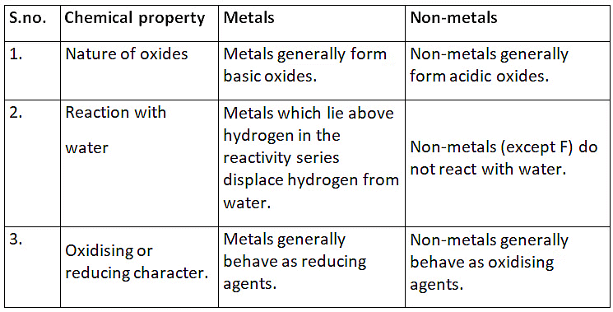
(b) (i) Metals conduct electricity due to the flow of free electrons present in them.
(ii) The reaction of iron (III) oxide, Fe₂O₃ with aluminium is highly exothermic and the iron produced melts. This molten iron is used to join cracked iron parts of machines and railway tracks.
