The Human Eye and the Colourful World
CLASS-10TH PHYSICS PYQ (STUDY MATERIAL)
Previous Year Questions 2024
Q1: The lens system of human eye forms an image on a light sensitive screen, which is called as: (2024)
(a) Cornea
(b) Ciliary muscles
(c) Optic nerves
(d) Retina
Ans: (d)
The lens system of the human eye forms an image on a light-sensitive screen called the retina. The retina captures the light and sends the visual information to the brain through the optic nerves, allowing us to see.
Q2: Study the diagram given below and answer the questions that follow: (2024)
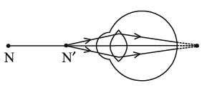(i) Name the defect of vision represented in the diagram. Give reason for your answer.
(ii) List two causes of this defect.
(iii) With the help of a diagram show how this defect of vision is corrected.
Ans: (i) Hypermetropia or Far-sightedness.
Reason – Image is formed behind the retina. Near point for the person is farther away from the normal near point (25 cm)
(ii)
- Focal length of the eye lens is too long.
- The eyeball has become too small.
(iii)
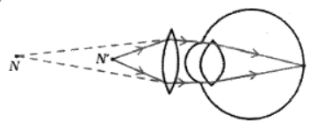N = Near point of a hypermetropic eye
N’= Near point of a normal eye
Q3: Consider the following statements in the context of human eye: (2024)
(A) The diameter of the eye ball is about 2.3 cm.
(B) Iris is a dark muscular diaphragm that controls the size of the pupil.
(C) Most of the refraction for the light rays entering the eye occurs at the crystalline lens.
(D) While focusing on the objects at different distances the distance between the crystalline lens and the retina is adjusted by ciliary muscles.
The correct statements are —
(a) (A) and (B)
(b) (A), (B) and (C)
(c) (B), (C) and (D)
(d) (A), (C) and (D)
Ans: (a)
Adult eyeballs measure around 2.3 cm in diameter. The iris is the dark muscular diaphragm, whereas the ciliary muscle adjusts the focal length to focus images on the retina. The eye's initial surface, where light transitions from air to the cornea, has the most substantial shift in its index of refraction. The cornea accounts for around 80% of refraction, whereas the inner crystalline lens accounts for 20%.
Q4: Assertion - Reason based questions: (2024)
These questions consist of two statements — Assertion (A) and Reason (R). Answer these questions selecting the appropriate option given below :
Assertion (A): Myopic eye cannot see distant objects distinctly.
Reason (R): For the correction of myopia converging lenses of appropriate power are prescribed by eye-surgeons.
(a) Both (A) and (R) are true and (R) is the correct explanation of (A).
(b) Both (A) and (R) are true, but (R) is not the correct explanation of (A).
(c) (A) is true, but (R) is false.
(d) (A) is false, but (R) is true.
Ans: (c)
The assertion (A) states that a myopic eye, or nearsighted eye, cannot see distant objects clearly, which is true. However, the reason (R) claims that converging lenses are used to correct myopia, which is false; instead, diverging lenses are prescribed for myopia to help the eye focus on distant objects. Thus, the answer is (c) because (A) is true, but (R) is false.
Q5: When do we say that a particular person is suffering from hypermetropia? List two causes of this defect. Name the type of lens used to correct this defect. (CBSE 2024)
Ans: When he cannot see nearby objects distinctly but can see far object clearly.
2 causes:
(i) Focal length of the eye lens is too long.
(ii) Eyeball becomes too small.
lens used to correct this defect is Convex or Converging lens
Q6: (a) Define the term power of accommodation of human eye. Write the name of the part of eye which plays a major role in the process of accommodation and explain what happens when human eye focuses (i) nearby objects and (ii) distant objects.
OR
(b) Draw a ray diagram to show the formation of a rainbow in the sky. On this diagram mark A — where dispersion of light occurs, B — where internal reflection of light occurs and C — where refraction of light occurs. List two necessary conditions to observe a rainbow. (2024)
Ans: (a)
- The ability of the eye lens to adjust its focal length, so as to clearly focus rays coming from distant as well as near objects on the retina, is called the power of accommodation of the eye.
- Ciliary muscles play a major role in maintaining power of accommodation.
(i) While focusing on nearby objects ciliary muscles contract, eye lens becomes thick and its focal length decreases.
(ii) While focusing on distant objects ciliary muscles relax, eye lens becomes thin and its focal length increases.
OR
(b)
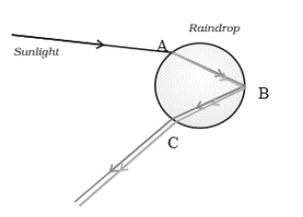
Two conditions:
(i) The Presence of tiny water droplets in the atmosphere.
(ii) Position of Sun at the back(behind) of the observer.
Q7: Name and explain the phenomenon of light due to which the path of a beam of light becomes visible when it enters a smoke filled room through a small hole. Also state the dependence of colour of the light we receive on the size of the particle of the medium through which the beam of light passes. (CBSE 2024)
Ans:
The phenomenon responsible is the Tyndall Effect, where light scatters due to tiny particles in the medium, making the beam visible in a smoke-filled room.
Dependence on Particle Size:
- Small Particles – Scatter shorter wavelengths (blue/violet) more, making the sky appear blue.
- Medium Particles – Scatter all wavelengths almost equally, making the light appear white.
- Large Particles – Scatter all wavelengths equally, giving a white or greyish appearance, like clouds.
Q8: When a beam of white light passes through a region having very fine dust particles, the colour of light mainly scattered in that region is: (2024)
(a) Red
(b) Orange
(c) Blue
(d) Yellow
Ans: (c)
When a beam of white light passes through an area with fine dust particles, the color of light that gets scattered the most is blue. This happens because shorter wavelengths of light, like blue, scatter more easily than longer wavelengths, like red or orange Therefore, blue light is not visible in such conditions.
Q9: Define the term power of accommodation of human eye. What happens to the image distance in the eye when we increase the distance of an object from the eye ? Name and explain the role of the part of human eye responsible for it in this case. (2024)
Ans:
- Power of Accommodation – The ability of the eye lens to adjust its focal length to focus objects at different distances on the retina.
- Image Distance – Remains unchanged as the image always forms on the retina.
- Role of Ciliary Muscles:
  - For Distant Objects – Ciliary muscles relax, lens becomes thin, focal length increases.
  - For Nearby Objects – Ciliary muscles contract, lens becomes thick, focal length decreases
Q10: (a) Study the diagram given below and answer the questions that follow: (2024)
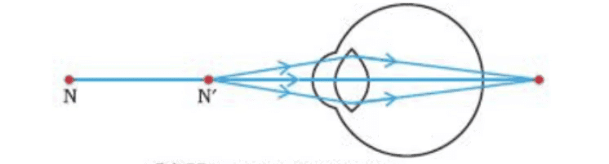
(i) Name the defect of vision depicted in this diagram stating the part of the eye responsible for this condition. (ii) List two causes of this defect. (iii) Name the type of lens used to correct this defect and state its role in this case.
OR
(b) What is dispersion of white light? State its cause. Draw a diagram to show dispersion of a beam of white light by a glass prism.
Ans:
(a) Defect of Vision
(i) Name & Responsible Part:
- Hypermetropia (Farsightedness) – Caused by ciliary muscles/eye lens.
(ii) Causes:
- Focal length of the eye lens is too long.
- Eyeball is too small, forming the image behind the retina.
(iii) Correction:
- Convex lens (Converging lens) decreases the focal length, helping focus the image on the retina.
(b) Dispersion of White Light
- Definition: Splitting of white light into seven colours when passing through a prism.
- Cause: Different colours bend at different angles due to varying wavelengths.
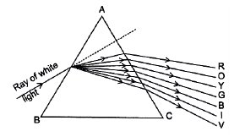
Q11: For Q. Nos.11 and 12, two statements are given - One labelled as Assertion (A) and the other labelled as Reason (R). Select the correct answer to these questions from the codes (a), (b), (c) and (d) as given below: (2024)
Assertion (A): The rainbow is a natural spectrum of sunlight in the sky.
Reason (R): Rainbow is formed in the sky when the sun is overhead and water droplets are also present in air.
(a) Both Assertion (A) and Reason (R) are true and Reason (R) is the correct explanation of the Assertion (A).
(b) Both Assertion (A) and Reason (R) are true, but Reason (R) is not the correct explanation of the Assertion (A).
(c) Assertion (A) is true, but Reason (R) is false.
(d) Assertion (A) is false, but Reason (R) is true.
Ans: (b)
- (A) is correct: A rainbow is a natural spectrum.
- (R) is False: Water droplets are required, but the sun must be behind the observer (not overhead) and near the horizon. Thus, (R) is factually incorrect about the sun's position.
Q12: Assertion (A) and Reason (R), answer these questions selecting the appropriate option given below: (CBSE 2024)
Assertion (A): Red light signals are used to stop the vehicles on the road.
Reason (R): Red coloured light is scattered the most so as to be visible from a large distance.
(a) Both (A) and (R) are true and (R) is the correct explanation of (A).
(b) Both (A) and (R) are true and (R) is not correct explanation of (A).
(c) (A) is true, but (R) is false.
(d) (A) is false, but (R) is true.
Ans: (c)
The assertion (A) is true because red light signals are indeed used to indicate that vehicles should stop. However, the reason (R) is false; red light is actually scattered the least among the visible colors due to longer wavelength , which is why it can be seen from a distance without much scattering. Therefore, the correct answer is (c), as (A) is true, but (R) is false.
Previous Year Questions 2023
Q1: Observe the following diagram and answer the questions following it :
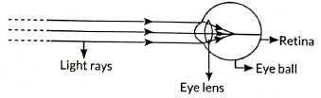
(i) Identify the defect of vision shown.
(ii) List its two causes.
(iii) Name the type of lens used for the correction of this defect. (2023)
Ans:
- Student is suffering from myopia.
- The two possible reasons due to which the defect of vision arises are:
  - excessive curvature of the eye-lens
  - elongation of the eye-ball
- A student with myopia has the far point nearer than infinity, thus, the image of a distant object is formed in front of the retina.
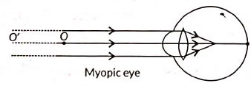
Correction of myopia: This defect can be corrected by using a concave lens of suitable power as it brings the image back on to the retina, thus the defect is corrected.
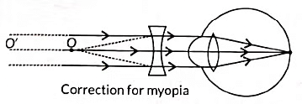
Q2: Observe the following diagram showing an image formation in an eye:
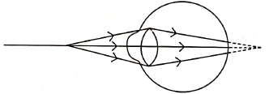
(a) Identify the defect of vision shown in the figure.
(b) List its two causes and suggest a suitable corrective lens to overcome this defect (2023)
Ans: (a) Hypermetropia
(b) Hypermetropia is caused due to following reasons:
(i) Shortening of the eyeball
(ii) Focal length of crystalline lens is too long
It is corrected by using a convex lens which converges and shifts the image to the retina from behind.
Q3: Define the term dispersion of white light. State the colour which bends (i) the most, and (ii) the least while passing through a glass prism. Draw a diagram to show the dispersion of white light. (2023)
Ans:
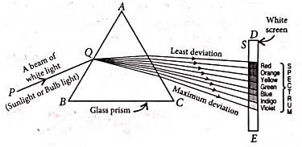(i) The phenomenon of the splitting up of the white light into its constituent's colours is called dispersion of light. Dispersion of light is caused due to different constituents and colours of light after different refractive indices to the material of the prism.
(ii) The formation of a rainbow is caused by the dispersion of the white sunlight into its constituent colours.
(iii) Based on the dispersion of white light into its constituent's colours, we can conclude that
(a) The white light consists of seven colours.
(b) The violet light suffers maximum deviations and the red light suffers minimum deviation.
Q4: What is a rainbow? Draw a labelled diagram to show its formation. (2023)
Ans: After a rain-shower, the sunlight gets dispersed by tiny droplets, present in the atmosphere. The water droplets act like small glass prisms. They refract and disperse the incident sunlight, then reflect it internally, and finally refract it again when it comes out of the raindrop. Due to dispersion or light and internal reflection, different colours reach the observer's eye, which is called a rainbow.
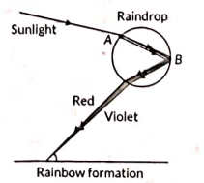
Q5: The colour of the clear sky from the Earth appears blue but from space, it appears black. Why? (2023)
Ans: As our earth has an atmosphere and space has no atmosphere, the sunlight scatters by the particles in the atmosphere. The amount of scattering of light is inversely proportional to wavelength thus violet, and blue colours scatter more than red and hence the colour of the sky appears blue from the earth.
Q6: A narrow beam XY of white light is passing through a glass prism ABC as shown in the diagram:
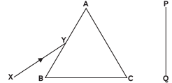
Trace it on your answer sheet and show the path of the emergent beam as observed on the screen PQ. Name the phenomenon observed and state its cause. (CBSE 2023)
Ans:
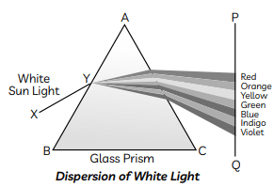
The phenomenon of the splitting up of the white light into its constituent colours is called dispersion of light. Dispersion of light is caused when different constituent colours of light offer different refractive indices to the material of the prism.
Q7: Give reasons for the following.
(A) Danger signals installed at airports and at the top of tall buildings are of red colour.
(B) The sky appears dark to the passengers flying at very high altitudes.
(C) The path of a beam of light passing through a colloidal solution is visible. (CBSE 2023)
Ans: (A) Among all the colours, red is scattered the least by smoke or fog. This is because the wavelength of red colour is the largest. Thus, it can be easily seen from a distance. Since the wavelength of red light is maximum in the spectrum, it’s penetration power in the air is maximum and so we can see red colour from farther distances. Thus, danger signal uses red colour.
(B) At higher altitude either the atmospheric medium is very rare or there are no particles present/no atmosphere, thus the scattering of light taking place is not enough at such heights or no scattering of sunlight takes place. Hence, the sky appears dark to the passengers flying at very high altitude.
(C) Tyndall effect deals with the phenomenon of scattering of light by colloidal particles. When a fine beam of sunlight enters a room, the particles present in the room become visible due to scattering of light by these particles. When sunlight passes through a canopy of a dense forest, tiny water droplets in the mist scatter light.
Q8: It is observed that the power of an eye to see nearby objects as well as far off objects diminishes with age.
(A) Give reason for the above statement.
(B) Name the defect that is likely to arise in the eyes in such a condition.
(C) Draw a labelled ray diagram to show the type of corrective lens used for restoring the vision of such an eye. (CBSE 2023)
Ans: (A) We know that the ability of the accommodation factor to alter the focal length declines with ageing. Without corrective spectacles, aged people have difficulty seeing surrounding objects clearly.
(B) The person is suffering from presbyopia.
(C)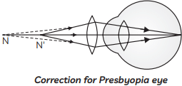

Previous Year Questions 2022
Q1: In the diagram given below. X and Y are the end colours of the spectrum of white light. The colour of 'Y' represents the (2022)
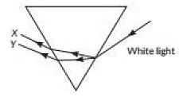
(a) Colour of sky as seen from earth during the day
(b) Colour of the sky as seen from the moon
(c) Colour used to paint the danger signals
(d) Colour of sun at the time of noon.
Ans: (c)
Sol: Red colour is used to paint the danger signals. As live know, visible spectrum has violet indigo, blue, green, yellow. orange and red colour and these colours are arranged with red on the top and violet at the bottom (near base of the prism) on the basis of wavelength and frequency, and among these colours red colour has largest wavelength (≈ 750 nm). Thus, here Y will be red.
Previous Year Questions 2021
Q1: Assertion (A): Sky appears blue in the day time. Reason
(R) : White light is composed of seven colours. (2021)
(a) Both A and R are true and R is the correct explanation of A
(b) Both A and R are true, and R is not correct explanation of A
(c) (A) is true, but R is false.
(d) (A) is false but R is true.
Ans: (b)
Sol: The blue colour of clear sky is due to scattering of sunlight
Q2: Which of the following statements is NOT true for the scattering of light?
(a) Colour of the scattered light depends on the size of particles of the atmosphere.
(b) Red light is least scattered in the atmosphere.
(c) Scattering of light takes place as various colours of white light travel with different speed in air.
(d) The fine particles in the atmospheric air scatter the blue light more strongly than red. So the scattered blue light enters our eyes. (CBSE Term-1 2021)
Ans: (c)
(a) This statement is true. The color of scattered light depends on the size of the particles in the atmosphere. Smaller particles scatter shorter wavelengths (like blue) more than longer wavelengths (like red).
(b) This statement is true. Red light is least scattered in the atmosphere because it has a longer wavelength.
(c) This statement is NOT true. All colors of white light travel at the same speed in air. Scattering occurs due to the interaction of light with particles, not because of a difference in the speed of various colors in air.
(d) This statement is true. Fine particles in the atmosphere scatter blue light more strongly than red light, which is why the sky appears blue to our eyes.
Therefore, the correct answer is (c) Scattering of light takes place as various colours of white light travel with different speed in air.

Previous Year Questions 2020
Q1: Why is the Tyndall effect shown by colloidal particles? State four instances of observing the Tyndall effect. (2020) Ans: The phenomenon of scattering of light by the colloidal particles gives rise to the Tyndall effect. When a beam of light strikes colloidal particles, the path of the beam becomes visible. This is known as the Tyndall effect. This phenomenon can be observed when
(i) Sunlight passes through a canopy of dense forest when tiny water droplets in the mist scatter light.
(ii) torch light is switched on in a foggy environment, light rays are visible after being scattered by the fog particles in the surrounding air.
(iii) a fine beam of sunlight enters a smoke-filled room through a small hole.
(iv) Shining a flashlight beam into a glass of dilated milk produces a Tyndall effect.
Previous Year Questions 2019
Q1: Define the term power of accommodation. Write the modification in the curvature of the eye which enables us to see the nearby objects. What are the limits of the accommodation power of a healthy normal human eye? (CBSE 2019)
Ans:
- Accommodation power is the property of the eye lens to adjust its focal length to focus objects situated at different distances from the eye on the retina.
- When the ciliary muscles are relaxed, the eye lens becomes thin and its focal length is maximum and equal to the diameter of the eyeball. In this condition, one can see distant objects.
- At the time of looking at nearby objects, the ciliary muscles of the eye contract and the eye lens become thicker. Consequently, the focal length of the eye lens decreases and nearby objects are focussed at the retina.
- There are definite limits to accommodation power for a healthy normal eye. The farthest distance, up to which an eye can see objects clearly, is called the far point of the eye and its value is infinity.
- The minimum distance, up to which an eye can see distinctly, is known as the near point of the eye and its value is 25 cm for a normal eye.
Q2: When do we consider a person to be myopic? List two causes of this defect.
Explain using a ray diagram how can this defect of an eye be corrected. (CBSE 2019)
Ans:
- A person is said to have a myopic vision if he can see objects situated near the eye clearly but cannot see distant objects.
- If a person can see clearly up to a distance x from the eye then it means that the far point of the eye has shifted from infinity to a point O situated at distance V from the eye.
- Light rays coming from a distant object (u = ∞) are focussed in front of the retina of the eye.
- Two possible causes of myopia are :
  - Either the power of the eye lens has become more than its normal value due to excessive curvature of the cornea (focal length of eye lens has decreased) or
  - Elongation of the eyeball due to some genetic defect.
- To rectify this defect a concave lens of focal length f is used, which may form the virtual image of the distant object at the far point of the defective eye (i.e., u = - ∞ and v = - x) so that now the defective eye may form the image at the retina.
- Obviously, by using the lens formula, we have
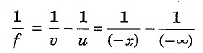⇒ f = -x
The ray diagram of the defective eye and its rectification are shown here.
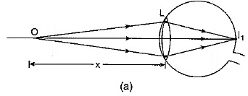Normal Eye 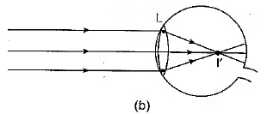Myopic Eye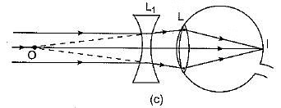Correction by concave lens
Q3: Name two defects of vision. Mention their cause and the type of lenses used to correct them. (CBSE 2019)
Ans: Two main defects of vision, their cause and correction are as follows :
(1) Myopia - In myopia or near-sightedness (or short-sightedness), a person can see nearby objects clearly but cannot see distant objects distinctly. For a myopic eye, the far point is not at infinity but has shifted nearer to the eye.
Myopia arises due to either (i) excessive curvature of the cornea, or (ii) elongation of the eyeball.
Myopia can be corrected by using a concave lens whose focal length has the same numerical value as the distance of the far point of the defective eye.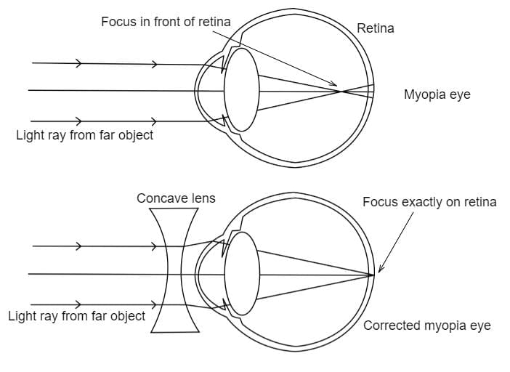
(2) Hypermetropia -In hypermetropia or long-sightedness, a person can see distant objects distinctly but cannot see nearby objects so clearly. For a longsighted eye, the near point is not at 25 cm but has shifted away from the eye.
Hypermetropia arises either because
(i) the focal length of the eye lens is too large, or
(ii) contraction of the eyeball.
Hypermetropia can be corrected by using a suitable convex lens, which forms a virtual image of the object situated at 25 cm at the near point of the defective eye so that the eye lens can focus it on the retina.
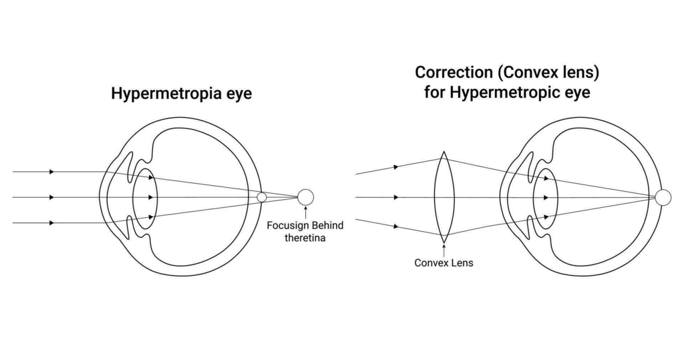
Q4: What is a rainbow? Draw a labelled diagram to show the formation of a rainbow. (CBSE 2019)
Or
Describe the formation of the rainbow in the sky with the help of a diagram.
Ans: A rainbow is a natural spectrum appearing in the sky after a rain shower. A Rainbow is caused by the dispersion of sunlight by tiny water droplets hanging in the atmosphere after a rain shower. The water droplets act like small prisms. As shown in the figure, the water droplets refract and disperse the incident sunlight. These rays are then reflected internally and finally refracted again and come out of raindrops. Due to the dispersion and internal reflection of light different colours reach the observer’s eye and a rainbow is seen.
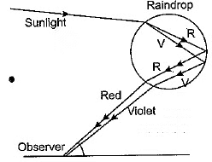An important point to be noted here is that a rainbow is always formed in a direction opposite to that of the Sun.
Q5: What is atmospheric refraction? Briefly explain. Why does the apparent position of a star appear different from its true position? (CBSE 2019)
Ans: The atmospheric air layer just near the earth's surface is comparatively denser and the upper layers of the atmosphere are successively rarer and more rarer. Hence, a light ray passing through atmospheric air undergoes refraction. Since the physical conditions of air are not stationary, the apparent position of the distant object, as seen through the air, fluctuates. It is known as an effect of atmospheric refraction.
Light coming from a distant star entering into the earth’s atmosphere gradually bends towards the normal on account of atmospheric refraction. Hence, the star appears slightly higher than its actual position when viewed near the horizon.
Q6: The stars appear higher from the horizon than they are. Explain why it is so. (CBSE 2019)
Ans: As we go up and up in earth’s atmosphere, it goes on becoming rarer and more rarer. As a result, the atmospheric layer near the earth’s surface has a maximum refractive index and the refractive index gradually decreases with an increase in height.
When a light ray from a star enters into earth’s atmosphere, it travels from a rarer to denser medium and hence continues to bend towards the normal. As a result, an observer on Earth considers the apparent position of a star to be at a higher altitude.
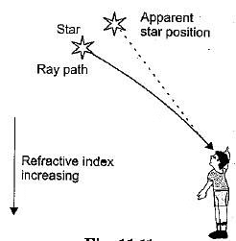
Q7: What happens to the image distance in the normal human eye when we decrease the distance of an object, say 10 m to 1 m? Justify your answer. (Delhi 2019)
Ans: There is no change in the image distance in the eye. The eye lens can adjust its focal length called accommodation. When object distance decreases, ciliary muscles contract and lens becomes thick and its focal length decreases. It facilitates near vision.
Q8: Due to the gradual weakening of ciliary muscles and diminishing flexibility of the eye lens a certain defect of vision arises. Write the name of this defect. Name the type of lens required by such persons to improve their vision. Explain the structure and function of such a lens. (Delhi 2019)
Ans:
- The defect of vision is Presbyopia.
- A bifocal lens is required by such persons to improve their vision.
Structure and function of Bifocal lens
- To view far-off objects, the upper part of the bifocal lens is a Concave or Diverging lens.
- To facilitate or view nearby objects, the Lower part of the bifocal lens is Convex or Converging lens.
Q9: (A) State the role of ciliary muscles present in our eye.
(B) Identify the defect of vision in each of the given cases and suggest its corrective measure.
(i) The eye lens has become milky and cloudy.
(ii) The eye lens has excessive curvature.
(iii) The eye lens has large focal length (longer than normal).
(iv) Ciliary muscles have weakened.
Ans: (A) Ciliary muscles relax and contract to adjust/modify the focal length of eye lens.
(B) Eye defects and corrective measures:
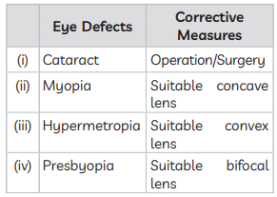
Q10: (A) With the help of diagram explain Isaac Newton’s experiment that led to the idea that the sunlight is made up of seven colours.
(B) What is atmospheric refraction? List two natural phenomena based on atmospheric refraction.
Ans: (A) Issac Newton was the first to use a glass prism to obtain the spectrum of white light. He tried to split various colours of the spectrum of white light by using another similar prism, but he could not get any more colours. Thus he proved that sunlight is made of seven colours.
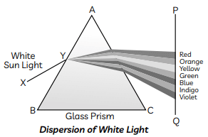
(B) Atmospheric Refraction: It is the refraction of light by the earth’s atmospheric layers having varying refractive indices.
Two natural phenomena:
(1) Twinkling of stars,
(2) Advanced sunrise and delayed sunset.
Previous Year Questions 2018
Q1: (a) Write the function of each of the following parts of the human eye :
(i) Cornea
(ii) Iris
(iii) Crystalline lens
(iv) Ciliary muscles.
(b) Why does the sun appear reddish early in the morning? Will this phenomenon be observed by an astronaut on the Moon? Give a reason to justify your answer. (CBSE 2018)
Ans: (a) The function of the given parts is stated below:
(i) The cornea is the outer bulged-out thin transparent layer of the eye and provides most of the refraction for the light entering into the eye.
(ii) The iris controls the size of the pupil of the eye.
(iii) The crystalline lens provides the finer adjustment of the focal length required to focus objects situated at different distances in front of the eye on the retina.
(iv) The ciliary muscles help in controlling the curvature of the crystalline lens and thus can change the power of the crystalline lens.
(b) In the early morning, the Sun is situated near the horizon. Light from the Sun passes through thicker layers of air and covers a larger distance in the Earth's atmosphere before reaching our eyes. While passing through atmosphere blue light is mostly scattered away and the Sun appear reddish as shown in Fig.
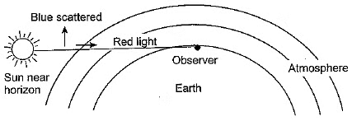
The phenomenon is not observed by an observer on the Moon because the Moon has no atmosphere of its own and hence no scattering of light is possible.
Q2: (a) What is meant by the term power of accommodation? Name the component of the eye that is responsible for the power of accommodation.
(b) A student sitting at the back bench in a class has difficulty in reading. What could be his defect of vision? Draw a ray diagram to illustrate the image formation of the blackboard when he is seated at the (i) back seat and (ii) front seat. State two possible causes of this defect. Explain the method of correcting this defect with the help of a ray diagram. (CBSE 2018)
Ans: (a) Power of accommodation: The ability of an eye lens to adjust its focal length to form a sharp image of the object at varying distances on the retina is called the power of accommodation. The ciliary muscles of the eye are responsible for changing the focal length of the eye lens.
(b)
- The student is suffering from myopia shortsightedness or nearsightedness.
- When a student is seated in the back seat.
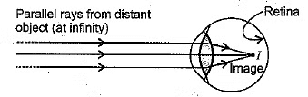
In this case, the student is suffering from myopia and has a short focal length of the eye lens.
(ii) When a student is seated in the front seat.
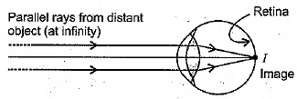
Causes:
(i) Excessive curvature of the eye lens
(ii) Elongation of eyeball.
The defect is corrected by using a concave lens of suitable power placed in front of the eye as shown below. It diverges the rays and forms a virtual image of a distant object at the far point of the myopic eye. These diverged rays enter the eye and form the image on the retina. Thus, the concave lens shifts the image back onto the retina instead of in front of it and the defect is corrected.
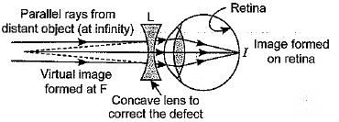
Q3: (a) What is presbyopia? State its cause. How is it corrected?
(b) Why does the sun appear reddish early in the morning? Explain with the help of a labelled diagram. (CBSE 2018C)
Ans: (a) (i) Presbyopia
- Presbyopia is a condition that occurs as a part of normal ageing.
Due to loss of power of accommodation of the eye, with age, objects at a normal near working distance will appear blurry. The near point gradually recedes away. This defect of the eye is called Presbyopia.
- Sometimes, a person may suffer from both myopia and hypermetropia.
(ii) Presbyopia is caused due to
- weakening of ciliary muscles, and
- eye lens becomes less flexible and elastic, i.e. reducing the ability of the eye lens to change its curvature with the help of ciliary muscles.
(iii) A bifocal lens will be required to see nearby as well as distant objects. For myopic defects, the upper part of the bifocal lens consists of a concave lens used for distant vision and to correct hypermetropia, the lower part of the bifocal lens consists of a convex lens. It facilitates near vision.
(b) At the time of sunrise/sunset, the sun is near the horizon, so the sun's rays have to travel through a larger atmospheric distance. The fine particles of the atmosphere scatter away the blue component and other shorter wavelengths of the sunlight. As λ_{b} < λ_{r}, only red colour having a longer wavelength and is least scattered, reaches our eyes. Hence, the sun appears red at sunrise or sunset.
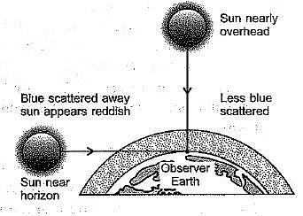
Practice Questions:
Q1: What eye defect is hypermetropia? What are its two possible causes? Describe with a ray diagram how this defect of vision can be corrected by using an appropriate lens. (CBSE 2017)
Q2: What is dispersion of white light? Draw a neat diagram to show the dispersion of white light by a glass prism. What is the cause of dispersion? (CBSE 2017)
Q3: State the cause of dispersion of white light by a glass prism. How did Newton, using two identical glass prisms, show that white light is made of seven colours? Draw a ray diagram to show the path of a narrow beam of white light, through a combination of two identical prisms arranged together in an inverted position concerning each other, when it is allowed to fall obliquely on one of the faces of the first prism of the combination. (AI 2017)
Q4: Name the type of defect of vision a person is suffering from, if he uses convex lenses in his spectacles for the correction of his vision. If the power of the lenses is +0.5 D, find the focal length of the lenses. (AI2017C)
Q5: A student traces the path of a ray of light through a glass prism for different angles of incidence. He analyses each diagram and draws the following conclusion:
(I) On entering prism, the light ray bends towards its base.
(II) Light ray suffers refraction at the point of incidence and point of emergence while passing through the prism.
(III) Emergent ray bends

